Linking ParentPay Transactions Into PFM
Payments received from parents via ParentPay can be easily imported into PFM without the need for re-entry. There are a couple of bits of setup that need to be done, and after that it should be simplicity itself on a day to day basis.
- Creating/amending services in ParentPay
For PFM to recognise payments from parents, the service set up in ParentPay must note the PFM short code. Log into ParentPay and go to PAYMENT ITEMS. Click on VIEW OR EDIT an existing payment item. If the trip does not already exist you will need to create it using Create a new Payment Item.
Click on the item to edit then choose EDIT PAYMENT ITEM DETAILS
Scroll down for existing trips, until you reach the FINANCE AND ACCOUNTING area.
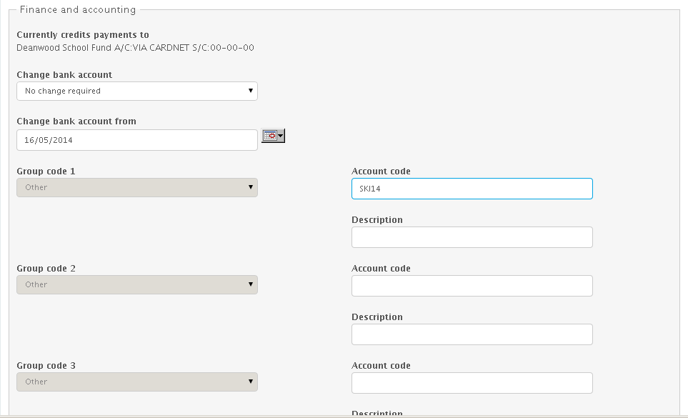
In the Group Code 1 - ACCOUNT CODE box, enter the short code of the trip from PFM. This must be exactly the same as on PFM – same spacing etc. It might be easier to COPY and PASTE from PFM to be sure it is identical. Save the amendment. (If you use Group code 1 for something else - SAP etc - enter the PFM code in Group code 2 or 3 but tell PFM in Tools - ParentPay options)

- Adding cash/cheques through ParentPay
If parents make all their payments through ParentPay, then the balance they owe will show correctly on ParentPay. However, if they pay some money through ParentPay and some as cash/cheques, then the ParentPay balance will not be up to date. A way round this is to use the option in ParentPay for entering Cash/Cheques as a batch. (FINANCE - CASH/CHEQUES) This will update the PP balance, and the transactions will then appear in PFM as cash/cheques waiting to be banked. Clearly, you should not ALSO enter them into PFM in the usual way, and this will lead to duplicates. Enter them into PP and then import entries from PP ready for banking along with other cash/cheques not related to trips on PP.
It is much more straightforward if parents do not mix and match online payments with cash and cheques for any given trip, but of course we can’t stop this happening.

- Downloading the list of payments received from ParentPay
You will be receiving payments from parents for trips etc., on an ongoing basis. Depending on the quantity, and how frequently you wish to update PFM with this information, you will need to download the report showing the payments received. If you want PFM to be up to date, then this will need to be done pretty regularly.
To download the report, go into ParentPay and to PAYMENT ITEMS Choose REPORTS.
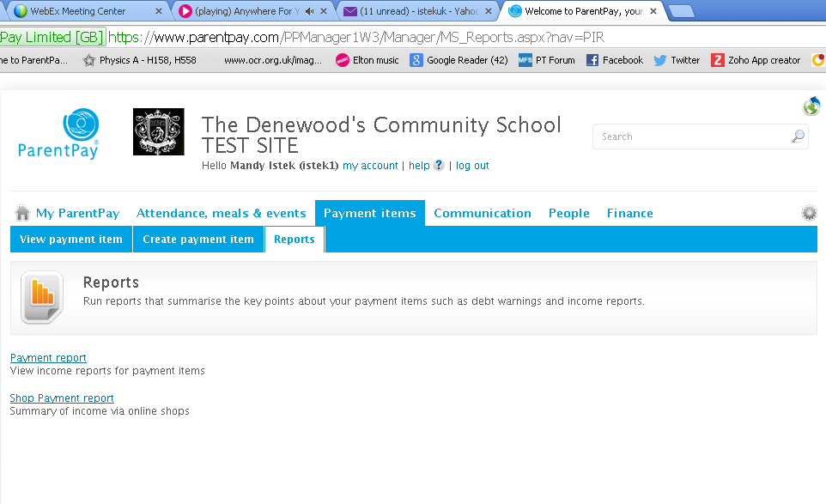
Full Excel Report

CLICK ON PAYMENT REPORT
DATE RANGE – this needs to overlap the previous report run. PFM needs to find at least one item it has already processed, to know where to start the new download from. It will not duplicate any entries. If there is no overlap, PFM will warn you, and you may have missing transactions.
Once the date range is selected, click on the third button – Excel Full Report. Choose to SAVE the spreadsheet created, and save it to the PFM folder – into the subfolder called UNPROCESSED INTERNET PAYMENTS. Make sure the Unprocessed folder is EMPTY when you save this new file to it – if there are any old files showing, delete them.
- Import the payments into PFM
Go into PFM – to Trans Entry – Receipts – Internet Receipts. Click on the button bottom left to READ INTERNET RECEIPTS FILE
PFM may find information in the file that it does not understand. If there is a short code that has been entered in ParentPay and is different on PFM, you will see a screen telling you the Group Code 1 is not valid. You will be able to select the Short Code that it should be showing.
PFM may find a pupil who is not on PFM – maybe a new starter, or pupil from another school. Again, you will be able to manually pick the student this money should be allocated to.
You can also choose to CANCEL the import, for example if you need to create a new short code for a new trip, or add a new student to the system.
Once complete, the grid onscreen will be populated with all the online payments received since your last download. The Trans Entry –Receipts – By Short Code will also have entries added for any cash/cheque you entered onto ParentPay. You can now BANK IT as required.

- Where do I BANK IT to?
Cash and cheques will be banked to the usual bank account in the usual way.
With online payments, you can choose – do the individual ParentPay transactions go straight to your school bank account? Or, do you receive a lump sum transfer from ParentPay once a week or fortnight? If the first case, you would BANK IT to the school bank account. In the second case, we would recommend setting up a dummy bank account called PARENTPAY HOLDING and bank all payments to this account. The payments sit here, until the lump is transferred out. (Create bank accounts in SETUP – ADD BANK ACCOUNT)
- Bank transfer when ParentPay transfer money to you.
If you receive a lump sum transfer weekly or fortnightly from ParentPay, record this on PFM using Transaction entry – Transfers – Bank Transfers. FROM – ParentPay holding , TO – School Fund bank account. Enter date and amount.
- Enter ParentPay’s Collection service invoice
Each time ParentPay transfer money to you, they will also issue a bill. The amount of the bill will be deducted from the amount of money you have received from parents, and the balance will be transferred to your school bank account.
You can view the bill by logging into ParentPay, and going to Reports – Reports - Collection service invoice
The invoice will need to be reflected on PFM. You will probably need to create a new short code for ParentPay Charges.
Enter the transaction through Trans Entry – Direct Postings – Payments. Select the short code, and use the PP dummy bank account (as it will be automatically deducted from here)

- Reconciliation –the final stage!
The last step is to reconcile the dummy ParentPay holding bank account. This will have all the monies in, the lump transfer out, and the invoice paid.
Log into ParentPay and go to Reports – Reports – Reconciliation report.
It will look something like this –
Settlement Date | Org | Service Name | Visa | Mastercard | Switch | Solo | Delta | Maestro | Electron | PayPoint | Cash |  | Cheque | Other Manual | Other | Total
17-Jan-12 | Greenpark High School | Stratford Girls Grammar Geography Trip | 225 | 0 | 0 | 0 | 0 | 0 | 0 | 0 | 0 |  | 0 | 0 | 0 | 225
17-Jan-12 | Greenpark High School | MK Academy trip to Caldicot Lake | 100 | 100 | 0 | 0 | 0 | 0 | 0 | 0 | 0 |  | 0 | 0 | 0 | 200
 |  |  |  |  |  |  |  |  |  |  |  | 425
18-Jan-12 | Greenpark High School | ASC 1 | 70 | 0 | 0 | 0 | 0 | 0 | 0 | 0 | 0 |  | 0 | 0 | 70 | 70
18-Jan-12 | Greenpark High School | MK Academy trip to Caldicot Lake | 0 | 30 | 0 | 0 | 0 | 0 | 0 | 0 | 0 |  | 0 | 0 | 0 | 30
18-Jan-12 | Greenpark High School | Stratford Girls Grammar Geography Trip | 300 | 350 | 0 | 0 | 0 | 0 | 0 | 0 | 0 |  | 0 | 0 | 0 | 650
 |  |  |  |  |  |  |  |  |  |  |  | 750
20-Jan-12 | Greenpark High School | Blythe Bridge visit to Derby Cinema | 0 | 0 | 0 | 0 | 0 | 60 | 0 | 0 | 0 |  | 0 | 0 | 0 | 0
20-Jan-12 | Greenpark High School | Park Hall trip to New York | 10 | 0 | 0 | 60 | 0 | 0 | 0 | 0 | 0 |  | 0 | 0 | 0 | 0
 |  |  |  |  |  |  |  |  |  |  |  | 130
25-Jan-12 | Greenpark High School | Greenpark High School Tie - blue/gold | 0 | 0 | 0 | 0 | 0 | 0 | 0 | 0 | 0 |  | 0 | 9 | 0 | 9
25-Jan-12 | Greenpark High School | KESH visit to Poland 2012 | 0 | 0 | 0 | 0 | 0 | 0 | 0 | 0 | 150 |  | 550 | 0 | 0 | 700
 |  |  |  |  |  |  |  |  |  |  |  | 709

Each day is subtotalled, so on 17th Jan £425 was received, on 18th Jan £750 and so on.
If we look at the Bank Statement area on PFM we see:
We have click on any transaction for 17th Jan and at the bottom we are offered a subtotal for that day. It totals £425 which is same as the ParentPay reconciliation for that date. We can therefore press the F1 functions key (at the top of the keyboard) and this will tick ALL the entries for 17th Jan that total £425.
If we click on 18th Jan it gives a total of £750 which also agrees with PP, so we can use F1 to tick all again.
Some days may not agree – this is usually when payment has been made by Mastercard or Solo, which can take a few days to clear. However, this is only usually true if you are reconciling very quickly – it is much better to leave it at least a week before reconciling – ie don’t try reconciling 17th January until at least 24th January – that way, slow payments will have cleared and your reconciliation should agree.
Once you have agreed a series of dates with the PP reconciliation reports, click on COMMIT CHANGES.

