Linking SQuid Transactions Into PFM
Payments received from parents via SQuid can be easily imported into PFM without the need for re-entry. There are a couple of bits of setup that need to be done, and after that it should be quite straightforward on a day to day basis.

- Setting up pupils in PFM to accept sQuid transactions.
PFM uses the SIMS admission number as a unique identifier for students. sQuid assigns its own special index to identify students, so before starting to import payments from we need to tell PFM what the index is for each child.
To do this, we will need an alphabetical list of all students with both UPN and sQuid number – this can be obtained from sQuid.
Open file in Excel – minimise and maximise PFM
Go to TOOLS – Update sQuid number
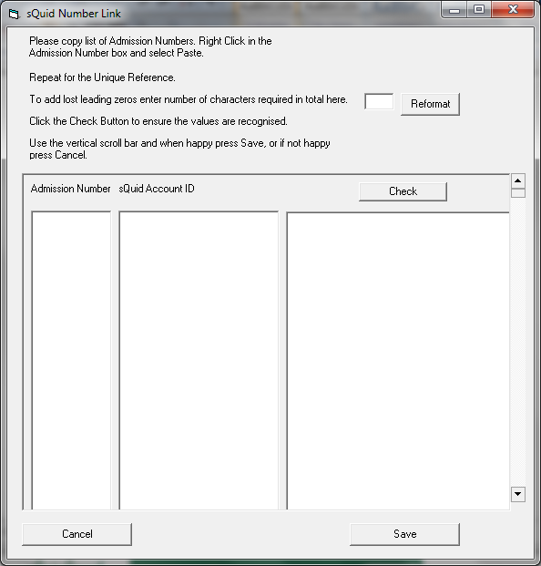
COPY and PASTE the list of Admission numbers from the spreadsheet onto column 1
COPY and PASTE the list of Unique numbers from the spreadsheet onto column 2.
Click on CHECK to confirm all values are correct. If so, click on SAVE.

- Creating a sQuid bank account of PFM
Money received from parents is paid to the school on a weekly basis, as a lump sum and not as individual payment. Therefore, it is very much advised that you create a sQuid holding bank account on PFM where daily transactions can be posted, and then transferred from, when sQuid make an actual payment to your bank account. Go to SETUP – ADD BANK ACCOUNTS
- Creating/amending Offers in sQuid
For PFM to recognise payments from parents, the Offer Description as set up in sQuid must be the same as the PFM code description. Log into sQuid and go to Offer Management System. If the trip does not already exist you will need to ADD NEW OFFER, otherwise use the SHOW OFFERS option.
The DESCRIPTION must be EXACTLY the same as the Description box in Private Funds Manager.
PFM looks at the Item Title used in sQuid to identify the shortcode. So when a new item for payment is created in sQuid the description used, must be the same as the description on PFM. If you want additional detail you can introduce a DOT on the code, and anything after the dot will be ignored when it links to PFM.

Eg – the Ski Trip Feb 2012 to Colorado might look like this :
PFM – Short code SKI12COL Description Ski Trip Feb 2012 Colorado
- Description - Ski Trip Feb 2012 Colorado Ski Trip Feb 2012 Colorado. Yr 11 would also work (extra details after dot)
Linking pupil reference numbers from PFM into sQuid
When creating a new offer on sQuid that is for a selected group of pupils and not the whole school, sQuid asks you to manually type in the reference numbers for all required students. This can be quite a time consuming and laborious task. An alternative, is to set up the trip in PFM and link the students to the trip in the ‘normal’way and then use the sQuid button in PFM to create the pupil list.
This shows on PFM in Accounts Maintenance , when you click on the STUDENT button –

Click on the sQuid button and a list of student reference numbers is copied to the clipboard.

You can now swap back to sQuid and use Right click and Paste to enter these references in the appropriate field.

- Downloading the list of payments received from sQuid
You will be receiving payments from parents for trips etc., on an ongoing basis. Depending on the quantity, and how frequently you wish to update PFM with this information, you will need to download the report showing the payments received. If you want PFM to be up to date, then this will need to be done pretty regularly.
To download the report, go into Offer Management System and to the SALES.

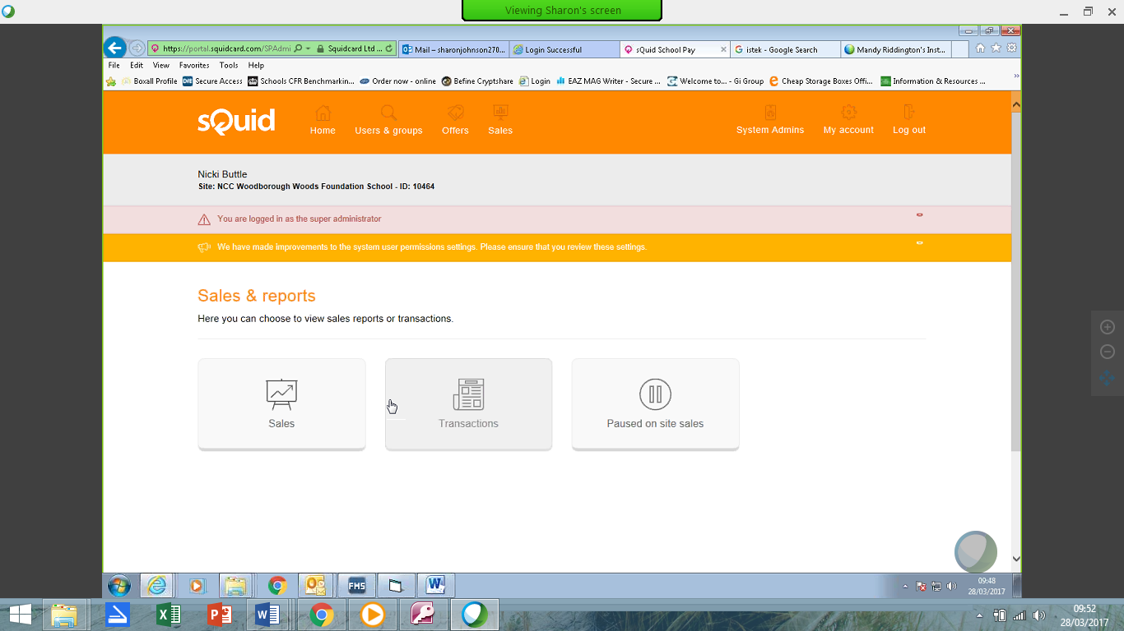
Choose TRANSACTIONS and SHOW FILTER
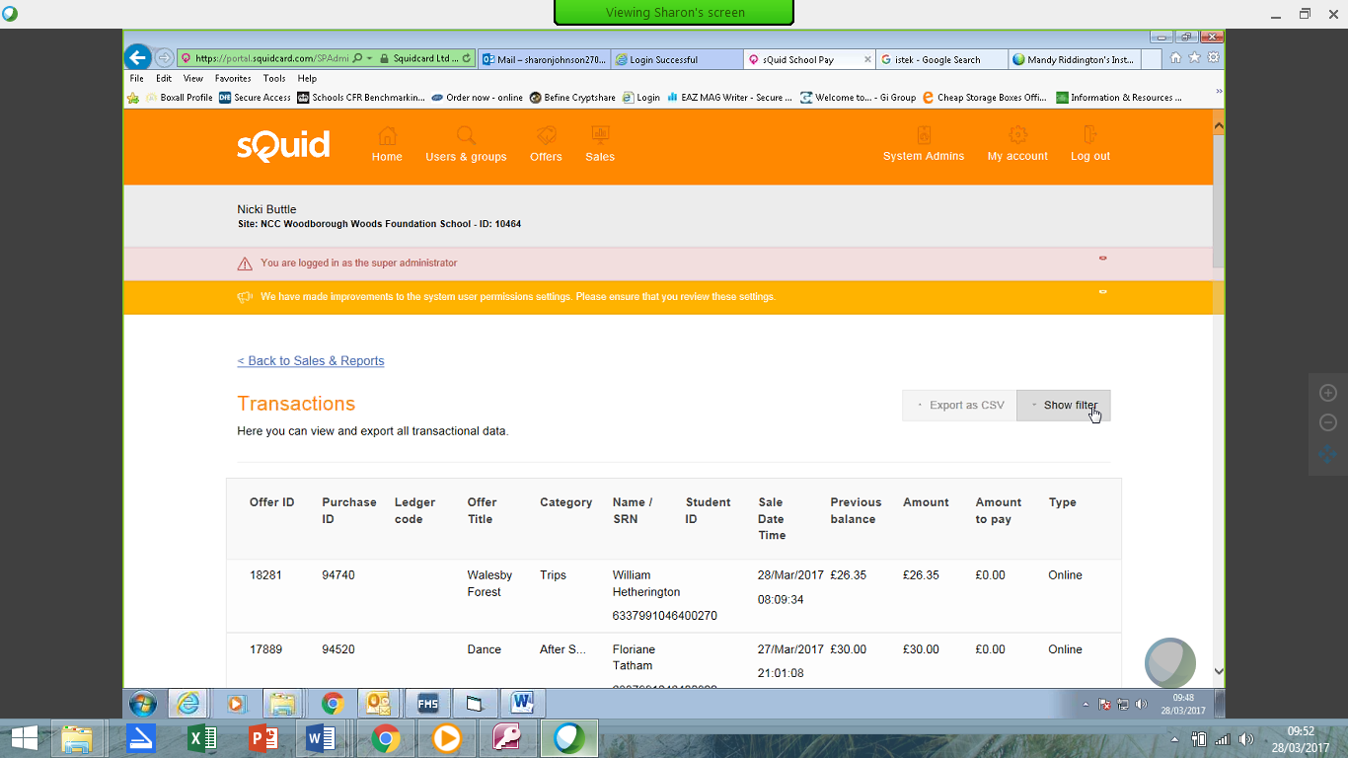
Enter the DATE range to extract payments for.
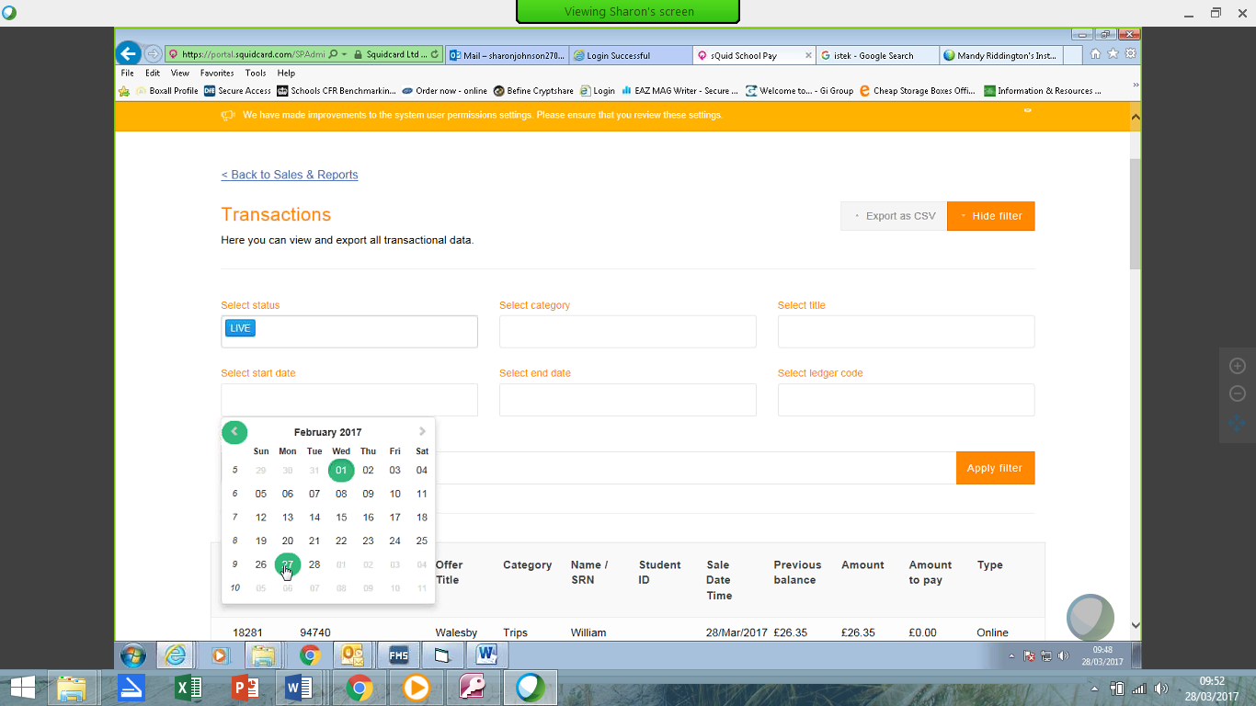
Click on EXPORT AS CSV

DATE RANGE – this needs to overlap the previous report run. PFM needs to find at least one item it has already processed, to know where to start the new download from. It will not duplicate any entries. If there is no overlap, PFM will warn you, and you may have missing transactions.
Save the CSV report into the UPROCESSED INTERNET PAYMENTS folder within the PFM folder. Make sure there are NO other files in this folder.
.
- Import the payments into PFM
Go into PFM – to Trans Entry – Receipts – Internet Receipts. Click on the button bottom left to READ INTERNET RECEIPTS FILE
PFM may find information in the file that it does not understand. If there is a short code that has been entered in and is different on PFM, you will see a screen telling you the Group Code 1 is not valid. You will be able to select the Short Code that it should be showing.
PFM may find a pupil who is not on PFM – maybe a new starter, or pupil from another school. Again, you will be able to manually pick the student this money should be allocated to.
You can also choose to CANCEL the import, for example if you need to create a new short code for a new trip, or add a new student to the system.
Once complete, the grid onscreen will be populated with all the online payments received since your last download. The Trans Entry –Receipts – By Short Code will also have entries added for any cash/cheque you entered onto . You can now BANK IT

- Receive money from sQuid
Money paid by parents is not received into the school bank account as received or on an individual basis, but is paid as a lump sum on a weekly basis. All transactions from Monday am to Sunday pm are settled the following Tuesday and in the schools account by that Thursday at the latest.
The payment is a net payment made up from total ePayments received less the transaction fee.
A settlement statement is received each Tuesday with gross payments taken each day and the gross weekly total as well as the amount of the transaction fee cost and the total net settlement value to be deposited in your bank account.
To enter the actual money received in your bank account from sQuid, go to Transaction Entry - Transfers – Bank Transfers
In the FROM select the sQuid bank account
In the TO select your school fund bank account
Enter the date, amount etc., as usual.

- Enter sQuid charges
Periodically sQuid will issue a charges bill. You will receive email notification of this bill.
The invoice will need to be reflected on PFM. You will probably need to create a new short code for Squid Charges.
Enter the transaction through Trans Entry – Direct Postings – Payments. Select the short code, and use the appropriate bank account (as it will be automatically deducted from here)

- Reconciliation –the final stage!
Use the settlement statement received each Tuesday to reconcile your sQuid account. This will list the gross payments taken each day which should tie up with the individual payments showing on PFM. The transaction fee cost will also show and can be ticked. Finally the settlement value deposited in your bank account should be ticked against the transfer.

