Entering ParentPay Transactions into PFM as Lump Sum

This option allows you to enter the money settled by ParentPay each week as lump sums to the various trips etc., without details of individual pupil payments.
First of all PRINT the SETTLEMENT Summary Report from ParentPay – in the REPORTS – FINANCIAL REPORTS area. Select the correct DATE range and select the correct SCHOOL FUND bank account.
A breakdown is shown at the bottom of the screen of all the TRIPS and how much has been received for each.
You are interested in the NET amount – ie the amount with FEES deducted

In PFM go to TRANS ENTRY – RECEIPTS – BANKING/BY SHORT CODE
First of all make sure the screen is EMPTY – so you might have to do a banking first.

Now select the first trip / account and enter the net amount in cash. Select the date the money was received and enter something in Notes to indicate the ParentPay week.

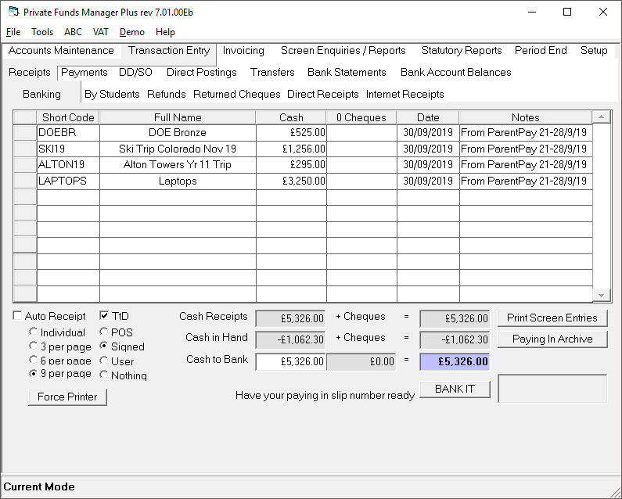
Repeat for all other trips/accounts – in the end the BOLD TOTAL TO BANK FIGURE at the bottom should equal the amount ParentPay have deposited in your bank account.

(If you accounted for fees separately and do not deducted from the trip income, you will need to create a SHORTCODE called PARENTPAY FEES – then enter them on this screen as a MINUS against the FEES short code)
Press BANK IT – enter ParentPay Settlement 29/9/19 in the Paying in Reference and change the DATE.

