Linking iPayimpact Transactions Into PFM
Payments received from parents via iPayimpact can be easily imported into PFM without the need for manual re-entry. There are a couple of bits of setup that need to be done, and after that it should be simplicity itself on a day to day basis.
- Creating/amending services in IPayimpact
For PFM to recognise payments from parents, the service set up in IPayimpact must have the SAME Description as on PFM. If you need a LONGER name on iPayimpact then use a DOT - then anything after the dot is ignored by PFM.
- Downloading the list of payments received from IPayimpact
You will be receiving payments from parents for trips etc., on an ongoing basis. Depending on the quantity, and how frequently you wish to update PFM with this information, you will need to download the report showing the payments received. If you want PFM to be up to date, then this will need to be done pretty regularly.
To download the report, go into IPayimpact and to the REPORTS area and choose PAYMENTS BETWEEN DATES .
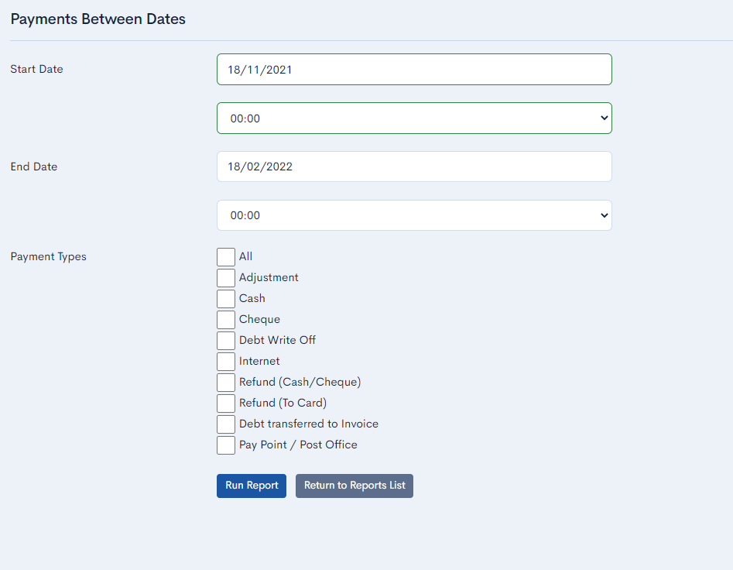
Enter a start and end date based on your previous download and tick ALL. Click RUN REPORT

When chosing a DATE RANGE – this needs to overlap the previous report run. PFM needs to find at least one item it has already processed, to know where to start the new download from. It will not duplicate any entries. If there is no overlap, PFM will warn you, and you may have missing transactions.
Full Excel Report

The spreadsheet created will look something like:
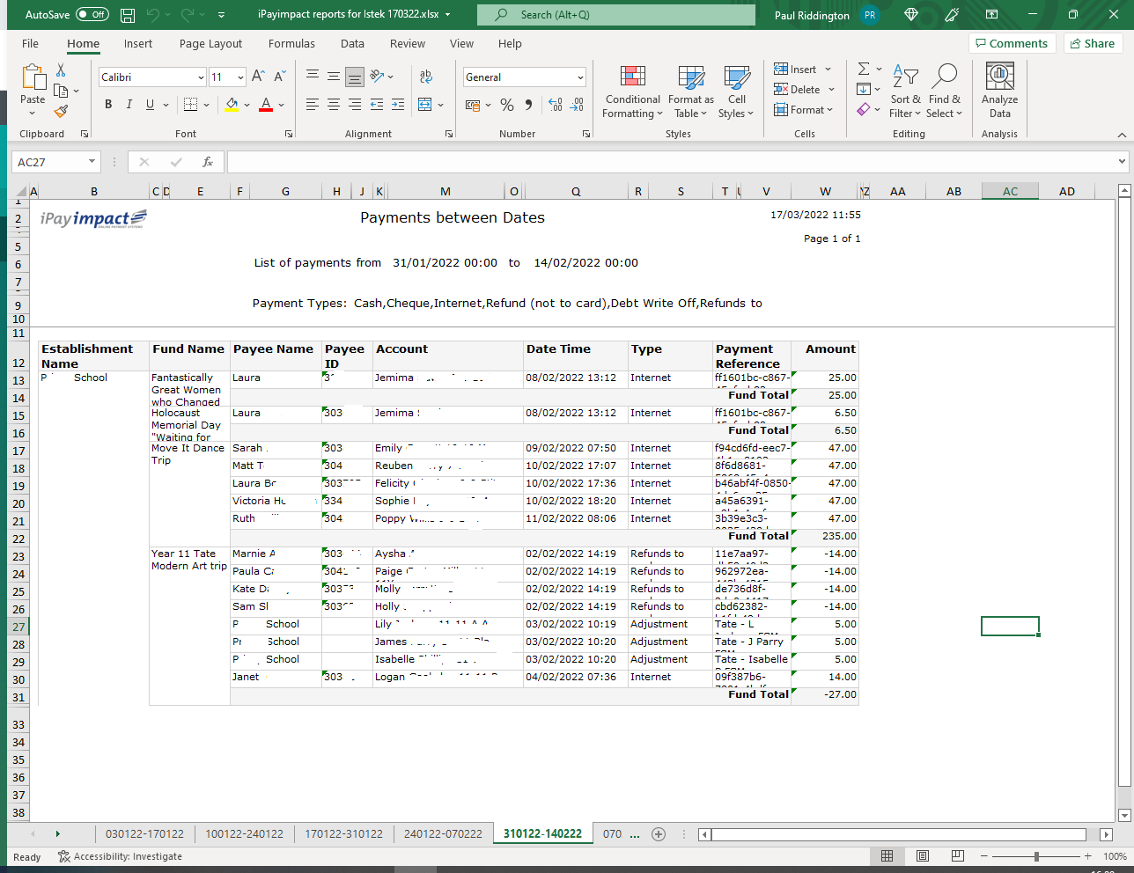

Select the option to OPEN the report, then when it is open select SAVE AS and CHANGE THE FILE TYPE to Excel Spreadsheet if it is not already this.
Save it to the PFM folder – into the subfolder called UNPROCESSED INTERNET PAYMENTS. Make sure the Unprocessed folder is EMPTY when you save this new file to it – if there are any old files showing, delete them.

- Import the payments into PFM
Go into PFM – to Trans Entry – Receipts – Internet Receipts. Click on the button bottom left to READ INTERNET RECEIPTS FILE
PFM may find information in the file that it does not understand. If there is a short code that has been entered in IPayimpact and is different on PFM, you will see a screen telling you the Cost Centre is not valid. You will be able to select the Short Code that it should be showing.
PFM may find a pupil who is not on PFM – maybe a new starter, or pupil from another school. Again, you will be able to manually pick the student this money should be allocated to.
You can also choose to CANCEL the import, for example if you need to create a new short code for a new trip, or add a new student to the system.
Once complete, the grid onscreen will be populated with all the online payments received since your last download. The Trans Entry –Receipts – By Short Code will also have entries added for any cash/cheque you entered onto IPayimpact, and there may be entries in Refund also – please check.
Anything on INTERNET RECEIPTS must be ‘banked’ straight away.
- Where do I BANK IT to?
Cash and cheques entered manually on IPayimpact will be banked to the usual bank account in the usual way together with the contents of the current paying in slip.
With online payments however, you will receive a SINGLE payment from IPayimpact comprising several or many individual online items (so five payments of £20 would appear as a single entry on the bank statement of £100, not five separate lines of £20). IPayimpact usually pay you weekly.
Because it is a LUMP payment, we recommend setting up a dummy bank account called something like IPY - IPAYIMPACT HOLDING and bank/save all payments to this account. The payments sit here, until the IPayimpact actually put REAL MONEY into your school bank account. (Create bank accounts in SETUP – ADD BANK ACCOUNT)

- Bank transfer when IPayimpact transfer money to you.
When you receive your settlement from IPayimpact, record this on PFM using Transaction entry – Transfers – Bank Transfers. FROM – IPayimpact holding , TO – School Fund bank account. Enter date and amount.

- Enter IPayimpact’s service invoice
IPayimpact charges a fee for each transactions processed. The transaction are deducted before the payments are settled – so if a parent pays £20, the school receives £20 less fees.
You will need to enter details of IPayimpact fees, and you will probably need to create a new short code for IPayimpact Charges.
Enter the transaction through Trans Entry – Direct Postings – Payments – select the FEES short code and the bank account is the HOLDING account.
- Reconciliation –the final stage!
The last step is to reconcile the IPayimpact transactions.
Ensure you have either a report detailing the payment period in question, or have a figure from your bank statement showing how much was received.
The holding bank account will have all the individual payments from parents going in, the lump transferred out when you receive your settlement and the fees.
Tick the bank transfer (for total amount received) and tick the fees.
Click on one of the transactions of money received and in the bottom right choose the option for WEEKLY THURSDAY-WEDNESDAY. (first time only)
A subtotal should now be shown for this period in the middle of the screen – check this is the amount of total received plus fees taken- if so press the F1 function key across the top of the keyboard, to tick them all (F5 unticks them all)
The Statement Closing Balance should now say ZERO. If it is not, make sure you have entered and ticked the bank transfer and fees payment.
When it does show ZERO press COMMIT CHANGES.

