Processing Gift Aid with Private Funds Manager

- What can be processed for gift aid?

School fund as a charity
A school charity is a charity associated with the running of a school. Gift Aid can be a simple and effective way to boost funding, and school charities are no different. Many donations made to school charities are eligible for Gift Aid, but it often goes unclaimed as school charities are unaware of what they can claim or feel Gift Aid is too complicated.
Gift aid can be claimed on income received for -
- Appeals to fund extra lessons
- Non-uniform days
- Schools fees
- Appeals towards school running costs
- Appeals to fund scholarships
- Appeals to a general reserve fund
- Educational school trips – see rules
- Appeals to buy a minibus or other equipment
- Sponsored events
- Payments to e-Learning Foundations
- Building appeals
- Other fundraising events

TRIPS -
A donation for a school trip will only qualify for Gift Aid if:
- there are no conditions attached to the donation, for example making attendance on the trip dependent on a donation being made - children of parents who do not contribute may not be discriminated against
- the donation is non-refundable even if the trip is cancelled - it must be a gift to the school with no conditions attached
- the value of any benefit arising from the school trip does not exceed the maximum level allowed

Benefit value limits on school trip donations
Donations for school trips do not qualify for Gift Aid if the overall cost of the trip (referred to as the 'benefit') exceeds a certain level in relation to the donation.
Benefit value limits for donations
Amount of donation | Benefit value limit
£0 -100 | 25% of the donation
£101 - £1,000 | £25
Above £1,000 donated up to and including 5 April 2007 | 5% of the donation

'Benefits' typically include travel costs, trip insurance, cost of entry, educational materials, cost of food and drink and any other costs associated with the trip. Costs can be averaged per pupil if appropriate.
In practice it is likely that the benefits associated with a school trip contribution will exceed the benefit limits and so the donation won't qualify for Gift Aid.
School trusts
An educational trust provides education for children as an alternative to state education. Parents or pupils (or other 'connected' people) are often asked to pay for textbooks, exercise books, exam fees and consumable materials. They may also be asked to make 'donations' to the trust instead of school fees.
Whether donations to the trust qualify for Gift Aid or not depends on how the money is used, and if the cost of providing the education is considered a benefit for Gift Aid purposes.
Payments for goods and services do not qualify for Gift Aid. So, payments for fees - including tuition fees and exam fees - and materials such as textbooks do not qualify for Gift Aid.
Donations used to cover the cost of education - If a trust uses donations to meet (even in part) the cost of educating a child - including the cost of tuition, heating and lighting of premises, administrative costs and other overheads - a benefit arises and donations by parents (or other connected persons) will not qualify for Gift Aid.
Donations not used to cover the cost of education -If donations do not contribute to the cost of education - for example, where a trust charges full fees or uses other regular income to cover the whole cost of educating a child - then a donation - for example, to buy prizes for a summer fête may qualify for Gift Aid. To qualify, the value of any benefits given in return for the donation must be below a certain value.

- Record keeping & Audit Requirements
You must keep records of donations received, the Gift Aid declarations relating to those donations - including any that are cancelled - and records of any benefits you have given in return for donations.
You must be able to show that your Gift Aid repayment claims are accurate and that all the conditions of Gift Aid are met - for example, that donations are for gifts of money and that the value of any benefits given in return are within certain limits. The records must also provide an audit trail linking each donation to an identifiable donor who has given a valid Gift Aid declaration.
If you don’t keep adequate records you may be required to pay back any tax reclaimed, with interest. You may also be liable to a penalty.
Gift Aid - declarations
Before you can claim tax on a donation made by an individual you need to:
- obtain a Gift Aid declaration from that donor to confirm that they want you to claim tax back for the donations specified
- advise them that they will need to pay at least as much UK tax in the tax year in which they donate as the amount you will reclaim on their donation(s)
There is no set design for a Gift Aid declaration, however, by law any Gift Aid declaration you obtain - whether written or verbal - must contain certain information such as the full name and home address of the donor. HM Revenue & Customs (HMRC) provides 'model' Gift Aid declarations for different situations - examples of Gift Aid declarations with wording printed on them to make them easy to use. By using a model declaration, and making sure your donor completes it in full, you can be confident that the declaration meets HMRC requirements.
Format and storage of Gift Aid declarations
You can decide how best to store your Gift Aid declarations, but your records must clearly show that each donor included in your repayment claim has made a declaration. You must keep an auditable record of Gift Aid declarations and of the making of them by the donor, whether the declarations are made on paper, electronically or orally. Declarations must be made available for review if required by HMRC.
Paper declarations can be kept in their original format. Or they can be scanned and stored electronically, as long as the records can be searched and individual declarations located as required. If you keep scanned copies which are fully auditable you can destroy the originals.
Transcription onto a separate list or database is not an acceptable alternative to keeping the original declarations, or scanned copies.
Records of donors who have made a declaration electronically, for example on a website, can be stored on a database.
If you use verbal declarations you could audio-record these in full at the time they are made. If you don’t do this you must confirm the declaration in writing to the donor and be able to provide evidence of this correspondence.
Records of cash donations
Linking cash donations to Gift Aid declarations needs care. If you receive regular cash donations from donors, for example in church collections, you might want to consider using an envelope scheme. This is where you can collect cash donations in envelopes so that they can show an audit trail linking the donation to the donor.
For one-off donations, you may choose to pre-print the Gift Aid declaration on the envelope for completion by the donor. If the donor is a regular supporter, you may already hold their Gift Aid declaration, in which case the envelope needs to show either the donor’s name or a unique identifier such as a reference number which can be cross-referenced to a donor register.
When the envelope is opened and the contents are counted, an official from your school should record the amount on the envelope it came in, and in a donor record. You should keep the envelopes as part of your normal record keeping.
Aggregating a claim
You can add together donations of less than £20 on the Gift Aid schedule, subject to a maximum total of £1000 per line within a claim. This is known as 'aggregating a claim' and means you don't have to list all the names of the individual donors who have given less than £20 on the schedule. You must have a Gift Aid declaration from each donor together with records itemising each individual donation included in the total. In the 'name of donor' box you should enter a descriptive label that will enable you to find the relevant Gift Aid declarations, such as the name and date of the event at which the money was donated. The aggregated claim must not include donations associated with admissions to charity visitor attractions or amounts paid for sponsored events. You also need to put a short note in the additional information box at the end of the form stating you have aggregated your claim in accordance with the guidance.
If your claim includes amounts paid for sponsored events for which there are a large number of donors, you do not need to include individual donor details. Instead, the schedule should list the amounts on each participator's sponsor form where Gift Aid declarations have been made. For each entry on the R68(i) Gift Aid schedule you should enter details of the event under the heading 'Name of Donor' and this must include the word 'sponsored,' for example, 'Sponsored Walk 14 August various participants'. The entry in the 'Total donation(s)' column should be the total of amounts on the sponsor sheet in respect of which Gift Aid declarations have been obtained. Again if you do this you need to include details in additional information box at the end of the form.
Records of benefits given to donors
You can give donors modest tokens of appreciation - called benefits - in order to acknowledge their gift, but there are strict limits on their value. You should keep records of all benefits given in return for donations received and show how these relate to specific donors (individuals or companies). You should also keep a record of the value of the benefits you provide, including how you arrived at the value.
How long should you keep records?
The time limits for keeping Gift Aid declarations and Gift Aid payment records are different and depend on how your charity is treated for tax purposes. Most schools must keep tax records (including Gift Aid declarations and records) for six years after the end of the accounting period they relate to.

- Processing Gift Aid in PFM
Transactions upon which gift aid can be reclaimed, can be processed on PFM in one of 3 ways.
- Cash / Cheque entries
- SO/Direct Debit or Bank Transfer entries
- Payments received via a 3rd party online payment provider

CASH / CHEQUES
DONORS
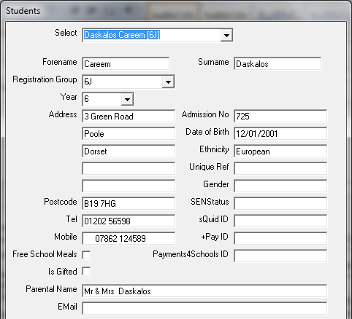
Donors are any persons who donate money for purposes that are subject to Gift Aid. Parental donors are automatically imported from Sims or other pupil record systems, when students are loaded and updated. You need to be using the latest version of PFM and of the pupil report –PFM2014/15 in Sims.
Check parental information has been imported by going to SETUP – Students – View/Amend/Add

Other donors will need to be entered onto PFM at the point of money receipt. Once entered however, they will stay on the system for subsequent use.
SHORT CODES
If you wish the moneys received for an account to be accounted for in Gift Aid, then the account must be setup as a gift aid account.
There are 2 types of gift aid account – one linked to a student in school, the other not.
For a student linked account change the TRACKING BY to BY INDIVIDUAL GIFT AID. For non-student linked choose LUMP SUM and click the GIFT AID box.
TRANSACTIONS – not linked to individual students
Record Gift Aid received in Transaction Entry - Receipts - By Short code
IF items are individually LESS THAN £20 aggregate them into a total EG this is a sponsored walk code
Select a gift aid account, and the following screen appears:
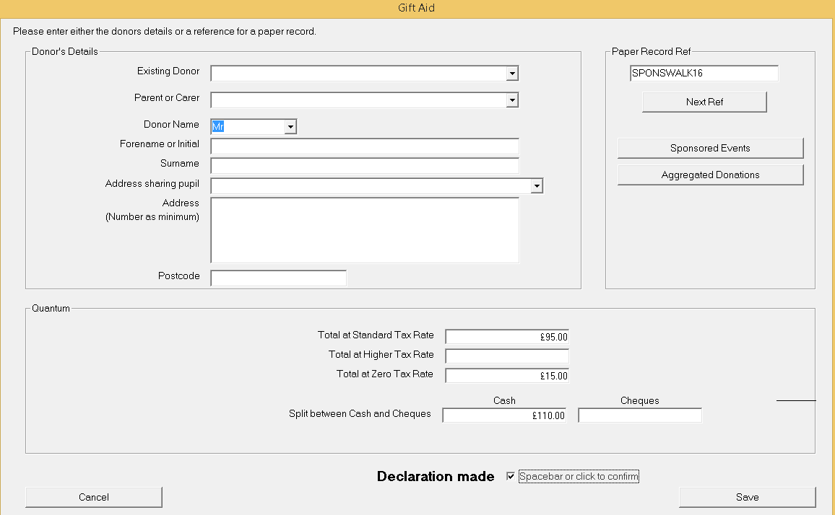
Enter a reference in the top right box that is THE SAME for all monies to the sponsored walk

Enter amount that is gift aidable
Enter amount not gift aidable
Tick Declaration made
Click SAVE

IF items are individually MORE THAN £20 they must be entered separately
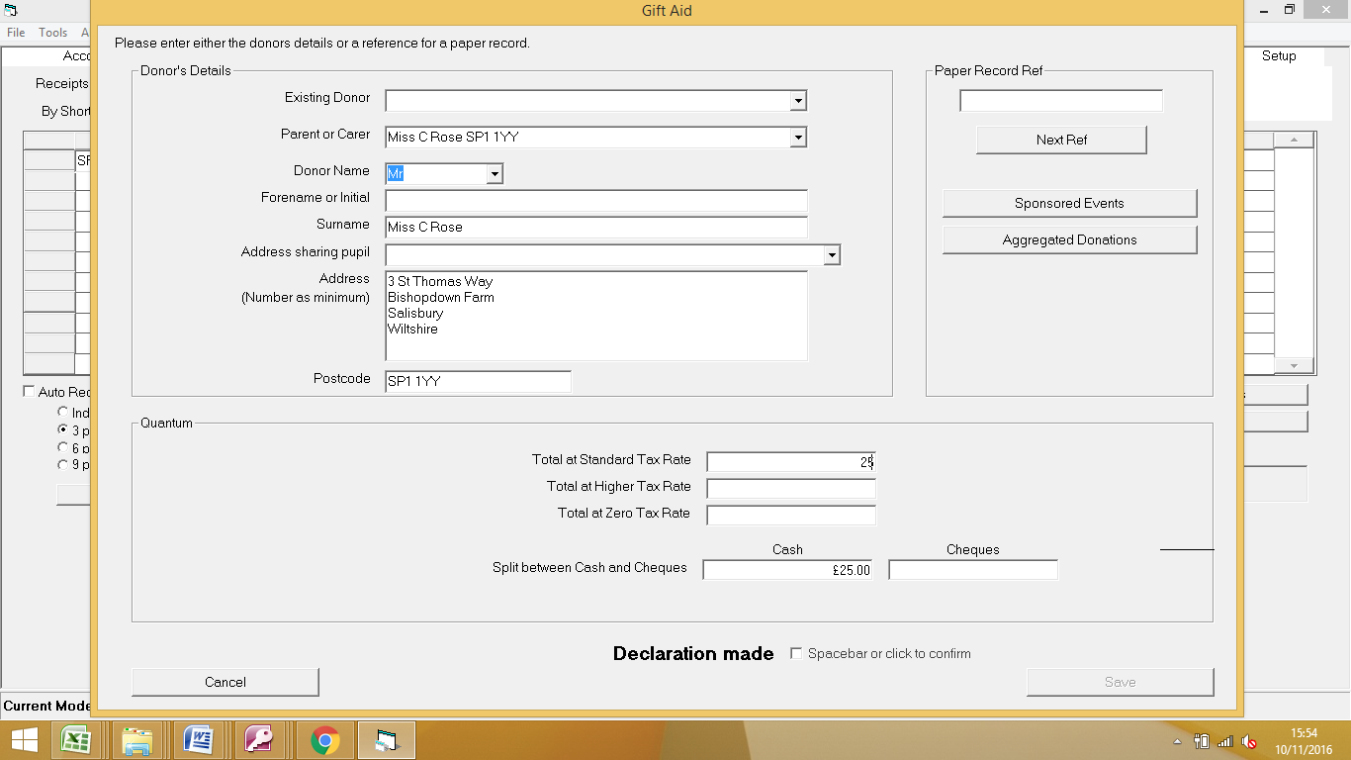
If the donor is a parent select then from the Parent pull down list.
Ensure it is the right parent by check the postcode that comes with the name.
Delete the salutation and initial from the name and enter the initial as appropriate.

Enter amount in Standard Tax rate or Zero if this parent cannot claim Gift Aid.
Enter as cash & cheque, and tick declaration made. Click on SAVE
---
If the donor is not a parent, but shares an address with a pupil, click on Address Sharing Pupil and select.
If the donor is not a parent and does not share an address, you will need to type in their details the first time they donate.
If a person has not given you a declaration leave the box unticked – you will not be able to reclaim on their donation.
If the person is not a UK tax payer, enter their amount in the ZERO tax rate box.

TRANSACTIONS – that ARE linked to individual students
Record Gift Aid received in Transaction Entry - Receipts - By Short code
Select a Gift Aid by Individual account and the following screen appears
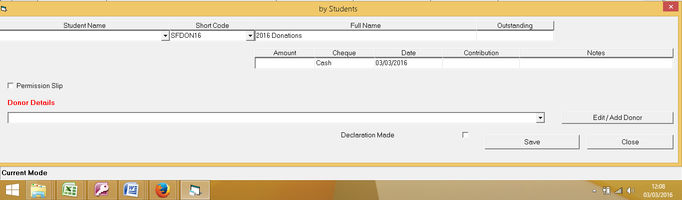

Choose the student the donation is linked to
Enter amount , if its cash or cheque
Choose the DONOR from the pull down list below – click EDIT if the initial or postcode is not showing.
Click ADD if the money is from someone else.
Click DECLARATION MADE box. SAVE

DIRECT DEBITS / STANDING ORDERS / BANK TRANSFERS
The latest version of PFM offers the facility to ready bank statements automatically and allocate the payments to the correct student, account and bank account. You need to have internet banking for this facility as we will be downloading statements from the internet.
Ideally this involves emailing or writing a letter to the parent and asking them to make payments through their internet banking system, and to enter a special code (unique to each pupil and trip) in the REFERENCE box . This special code identifies the pupil, trip etc.
However, we appreciate that many schools already have direct debits or standing orders set up with parents paying regularly, and rather than asking them to change something that is already set up we now have the facility to read existing transactions and for PFM to ‘learn’ who is who.
The first time you receive such a payment, you have to teach PFM who the payment is from and what it is for, but from them on it will be automatic.

Downloading bank statements from the internet
You might choose to do this every day, once a week or once a month. Each time, it will pick up the transactions that have been received in the date range selected.
As soon as a payment appears on your bank statement (which will generally be within 2 hours of the parent paying) you will be able to import the information automatically into PFM. Go to your online banking system and log in. Choose the option to EXPORT the data. SELECT THE DATE RANGE required. In each case choose the EXCEL or CSV format for your download.
On Barclays this shows as EXPORT MY DATA
On Lloyds this shows as EXPORT DATA
On Santander this shows as DOWNLOAD TRANSACTIONS
Others will say something similar.
A spreadsheet will be downloaded - SAVE that spreadsheet into the UNPROCESSED BANK STATEMENTS folder, within the PFM folder.

Read the bank statement entries into PFM
Now, go into PFM- TRANSACTION ENTRY - RECEIPTS - DIRECT RECEIPTS. Click on READ BANK STATEMENT FILE. It will do so, and a message something like the following will appear -

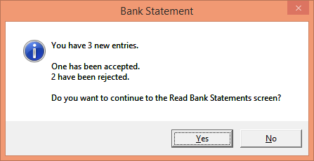
This is telling us that one of the entries has been identified automatically- the parent has been given a unique code and has used it when making the payment. However the other 2 have no code and at the moment have been rejected until you identify who they are.
Click on YES to continue to see the list of imported payments.
Across the top there are TABS and the selected one is ALL showing all transactions that you have downloaded this time.
Click on the TAB marked REJECTED to see the entries PFM did not recognise.
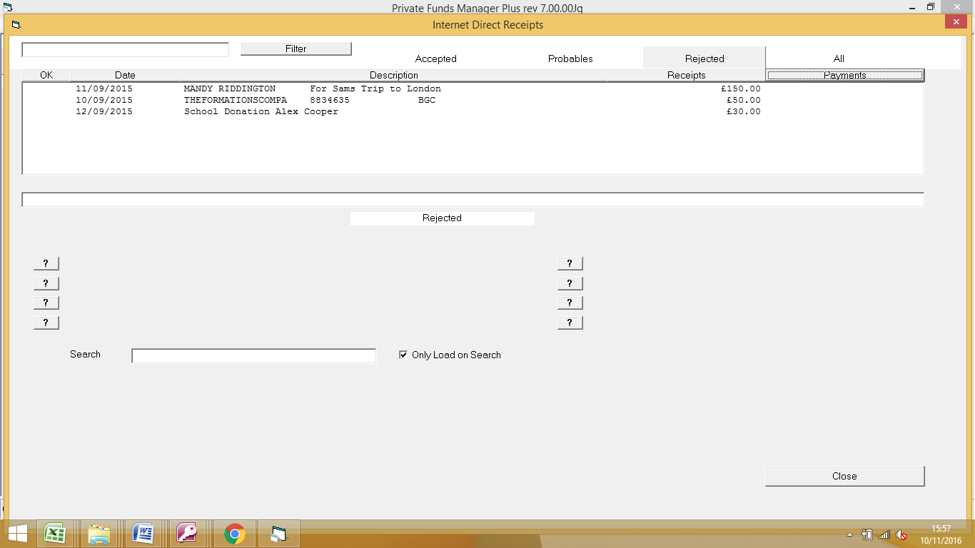
We can see that these are items that do show a name and that we probably can identify. The 3rd one is probably a donation that we need to import.
Click on the third one –
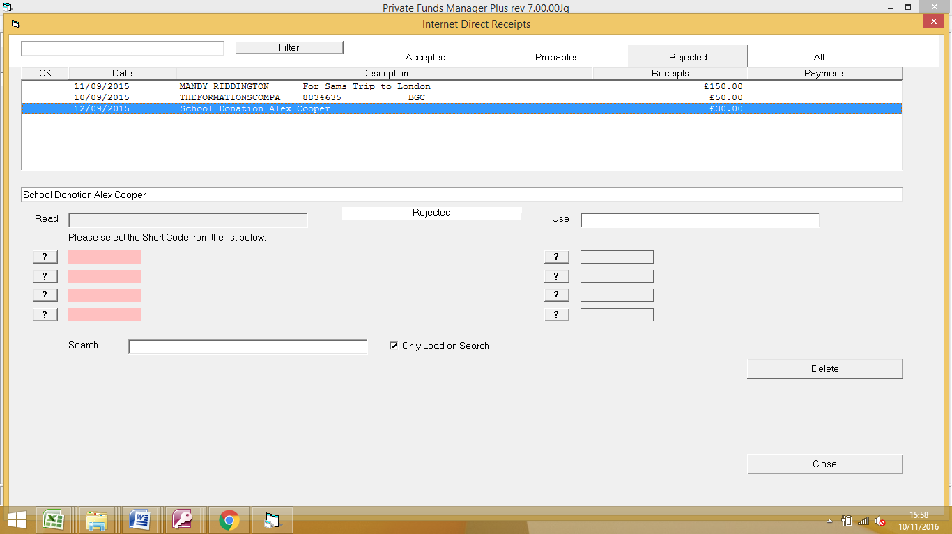
First of all choose the correct Short Code from the list showing at the bottom by typing the first letters of the code into the SEARCH box. Click the correct one
NEXT, we need to locate the student. Click on the SECOND ? box down on the right and a list of students appear at the bottom of the screen. In the Search box type anything that will help identify the student – I will type COOPER as this is the name on the bank statement.
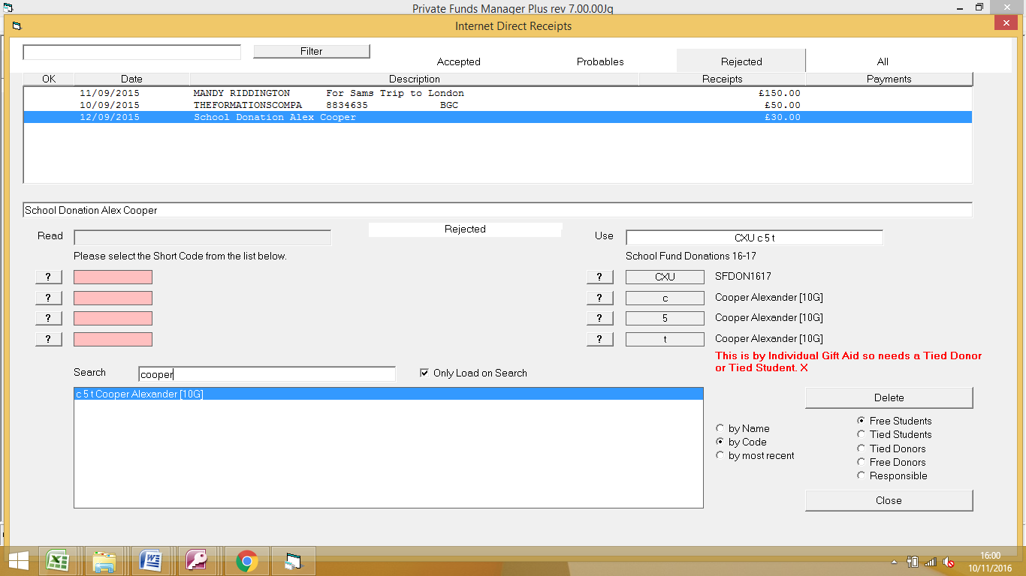
A list of possible COOPERs appears – in this case there is only one – so I can click to select him at the bottom. NOW however, I need to pick the correct Donor for him so click on TIED DONOR box on the right (ie the donor is tied to this student) and pick the donor from the list. Click on ACCEPT
Click on ACCEPT – message box will appear

Say YES so that all subsequent payments with this information showing on the bank statement , will automatically go the correct student/trip etc.

We now repeat the process with our other PROBABLE or REJECTED entries - teaching PFM who this is from.
Click on CLOSE and now all entries are sat waiting to be banked. Click on BANK IT.
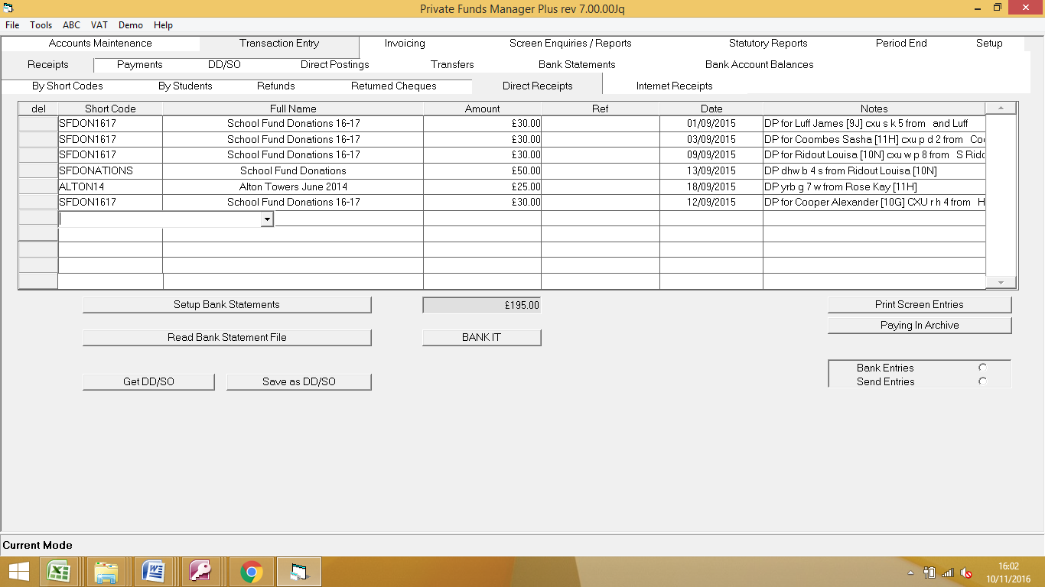

After the first month ALL standing orders and direct debits should be recognised automatically, unless there are new once started.
The download I have performed for the following month – same week – has found 23 automatically and only had 2 rejected that need matching up with the correct student and account.
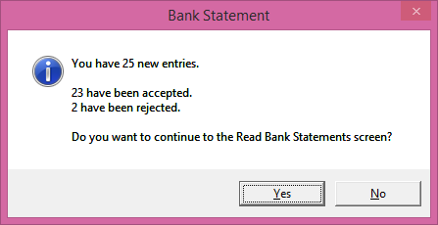

- REPORTS
Gift Aid Reports can be run from Statutory Reports – Gift Aid – Gift Aid Reports.
Select an appropriate date range – the financial year if you only claim annually, or quarterly etc., for more frequent reclaims.
Donor lists with and without declarations are for your use. The Without Declaration list can be used to chase donors up for their declaration, so you can claim on their donation.
The Gift Aid summary calculates what you are due to reclaim.
The Audit Trail and R68 are requirements of the Revenue.
The R68GAD is the new spreadsheet for gift aid returns required since 2013.
Before using the new R68GAD spreadsheet, you will need to download the spreadsheet template from our website, or email us and we can send this to you.

- Processing reclaim
When you receive the reclaim from HMRC, you can simply enter this onto the system as a cheque or a Direct Credit – depending on how it is received. Post it to an account in PFM that is not set up for Gift Aid!!

