Linking Arbor Transactions Into PFM

Payments received from parents via Arbor can be easily imported into PFM without the need for manual re-entry. You will first need to check the setup of the accounts on both Arbor and PFM to make sure that PFM can recognise what the payments are for.

1. **Setting up Arbor to link with PFM codes**

For PFM to recognise payments from parents, the ‘Description’ field set up in Arbor must be the same as the PFM code **description**.

In Arbor, access your accounts through SCHOOL – ACTIVITIES – TRIPS (or CLUBS)

The box marked DESCRIPTION must be EXACTLY the same as the Description box in Private Funds Manager.

PFM looks at the description to identify the shortcode.

So when a new item for payment is created in Arbor the description used, must be the same as the description on PFM.

If you want to say more on Arbor than on PFM, use a DOT on the Arbor description, and anything after the dot will be ignored when it links to PFM.

Eg – the Ski Trip Feb 2029 to Colorado might look like this :

PFM – Short code: SKI29COL Description: Ski Trip Feb 2029 Colorado

Arbor - Description - Ski Trip Feb 2029 Colorado OR Ski Trip Feb 2029 Colorado. Yr 11 OR Ski Trip Feb 2029 Colorado. Yr 11 MFL Trip for Groups A B and C. Anything AFTER THE DOT is IGNORED by PFM, so would import happily.

1. **Downloading the list of payments received from Arbor**

You will be receiving payments from parents for trips etc., on an ongoing basis. Depending on the quantity, and how frequently you wish to update PFM with this information, you will need to download the report showing the payments received. If you want PFM to be up to date, then this will need to be done pretty regularly – maybe weekly or even daily.

To download the report, go into Arbor and to:

SCHOOL - PAYMENTS - RECONCILIATION - MONEY RECEIVED

Select the required **DATE** RANGE in green above the tabs.

|  |
| --- |
| Full Excel Report |

Click CHANGE and amend dates, then be sure to click APPLY.

The date range needs to overlap the previous report run. PFM needs to find at least one item it has already processed, to know where to start the new download from. It will not duplicate any entries. If there is no overlap, PFM will warn you, and you may have missing transactions.

Select TRIPS as the **account type**

Save changes

Arbor then loads all TRIP payments received within the dates specified to the **screen**

Select DOWNLOAD TO EXCEL, from the drop-down top right

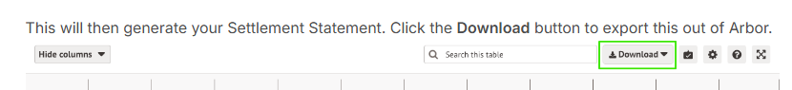

Copy this file to your **PFM/UNPROCESSED INTERNET PAYMENTS** folder.

Make sure the Unprocessed folder is EMPTY when you save this new file to it – if there are any old files showing, delete them.

1. **Import the payments into PFM**

Go into PFM – to TRANS ENTRY – RECEIPTS – INTERNET RECEIPTS.

Click on the button bottom left to READ INTERNET RECEIPTS FILE

PFM may find information in the file that it does not understand. If there is a description it does not recognise, you will see a screen telling you - will be able to select the correct Short Code.

PFM may find a pupil who is not on PFM – maybe a new starter, or pupil from another school. Again, you will be able to manually pick the student this money should be allocated to.

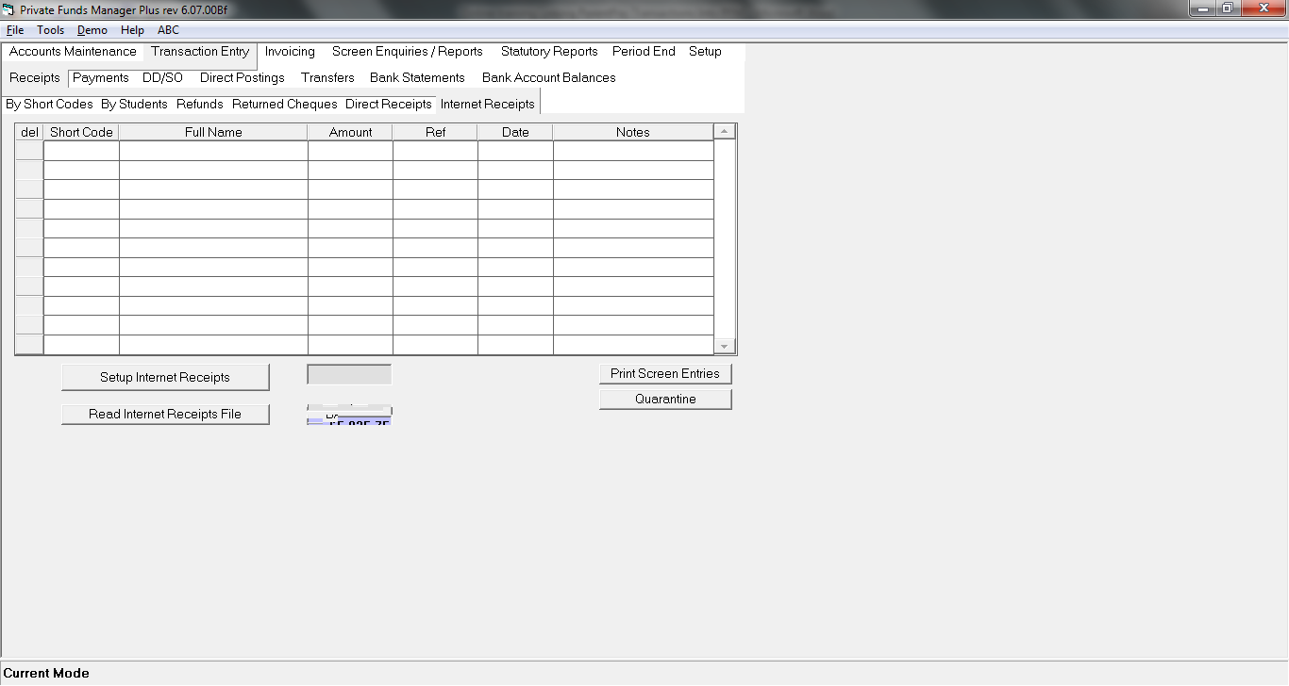You can also choose to CANCEL the import, for example if you need to create a new short code for a new trip, or add a new student to the system.

Anything on INTERNET RECEIPTS must be ‘banked’ straight away.

1. **Where do I BANK IT to?**

Online payments will be lumped together into a SINGLE payment comprising several or many individual online items (so five payments of £20 would appear as a single entry on the bank statement of £100, not five separate lines of £20).

Arbor pays out funds received from card payments to bank accounts on a weekly basis on Mondays (Sunday on the previous week to Saturday inclusive).

Because it is a LUMP payment, we recommend setting up a dummy bank account called something like ARB - ARBOR HOLDING and bank/save all payments to this account. The payments sit here, until Arbor actually put REAL MONEY into your school bank account. (Create bank accounts in SETUP – ADD BANK ACCOUNT)

1. **Bank transfer when Arbor transfer money to you.**

When you receive your settlement from Arbor, record this on PFM using Transaction entry – Transfers – Bank Transfers. FROM – Arbor holding , TO – School Fund bank account. Enter date and amount.

1. **Reconciliation –the final stage!**

The last step is to reconcile the Arbor transactions. The holding bank account will have all the individual payments from parent going in, the lump transferred out when you receive your settlement and any fees if deducted at source.

Use the Settlement Report for reconciliation:

**Settlement statement**

To get to the Settlement Statement go to SCHOOL - PAYMENTS - RECONCILIATION - CARD PAYMENTS - SETTLEMENT STATEMENT. This report is a highly detailed view of transactions that make up each payout. In the filter at the top of the page, you can select the date range and the report will list every individual transaction within that date range.

Click the green CHANGE button in the filter bar to edit the dates that you want to report on. Make sure to click Apply once you have set your dates.

This will then generate your Settlement Statement. Click the Download button to export this out of Arbor.

You can also filter the actual columns on the table (such as Customer Account Type or Description).

You can do this by:

Click the little arrow next to the column you want to filter.

Click the filter icon

Select in the tick boxes the results you want to see

Click somewhere on the page to remove the little pop up and see the results

You can now use this report to reconcile the holding account.