Linking ParentMail PMX Transactions Into PFM
Payments received from parents via Parentmail PMX can be easily imported into PFM without the need for re-entry. There are a couple of bits of setup that need to be done, and after that it should be quite straightforward on a day to day basis.
Setting up pupils in PFM to accept PMX transactions
PFM uses the SIMS admission number as a unique identifier for students. PMX assigns its own special index to identify students, so before starting to import payments from PMX we need to tell PFM what the PMX index is for each child.
If we do not do this process, then every time a pupil pays for the first time on PMX you will have to manually select the pupil on PFM - it will then learn who it is for future use. However, it is better to import the PMX IDs in advance to save this.
How to download a list of students and their PMX ID codes
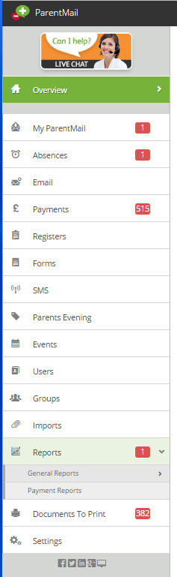
When logged into PMX, click onto Reports tab from the menu on the left hand side of PMX. This will then expand into two sub-tabs named: General Reports and Payment Reports. Click onto the ‘General Reports’ sub-tab to find a list of reports you can generate to extract different information you need. Please click onto the Parent/Student Export tab in the list.

Click onto the ‘Generate Report’ button, this will take a minute or two to generate a report and you will see the following screen:
Click OK and you will be notified for when the report has been generated. Underneath the Download heading, you wil have two options: CSV and PDF. Click onto the CSV green button, this will then automatically download or first ask you to save the file. Once you have opened this download, you will see a list of students and their PMX ID’s. SAVE this file to a location of your choice.
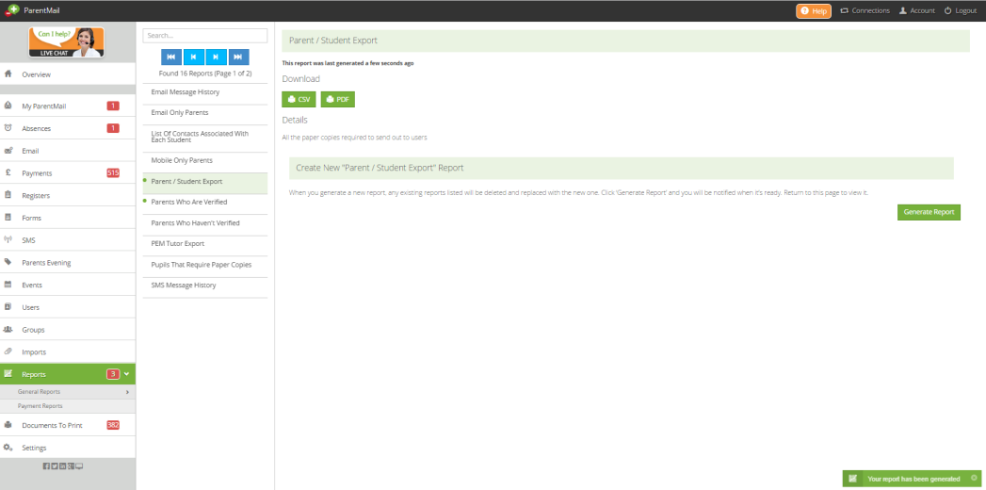

NOW RETURN TO PFM - In PFM go to TOOLS - PMX
Click on BROWSE - browse to the file created above, click on IMPORT.
If any of students do not match exactly, you will be offered possibilities. Accept or Scroll through to the next one until the correct student is identified.
The PMXIDs are now in PFM.

Creating/amending services in PMX
For PFM to recognise payments from parents, item in PMX must include an ACCOUNTING COST CODE.
How to set up a trip and where to enter Accounting Cost Codes
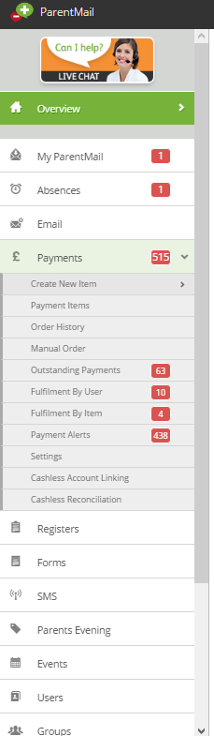
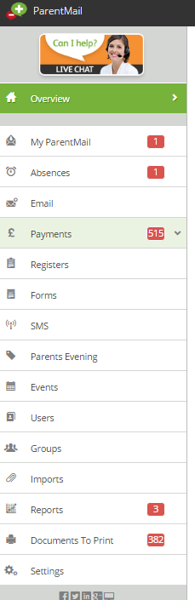
When logged into PMX, click onto Payments tab from the menu on the left hand side of PMX. This will then expand into 11 different sub-tabs. Please click onto the ‘create new item’ tab’.

- Create New – To create a payment item from scratch.
- Use Previous Item - If you have previously set up the payment item and need to adjust with different dates/prices, users etc.
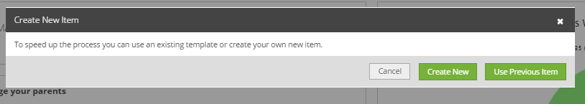

Both options have the same screen below:
- Create New – Blank fields.
- Use Previous Item – Fields will include information from previously set up that you can adjust.
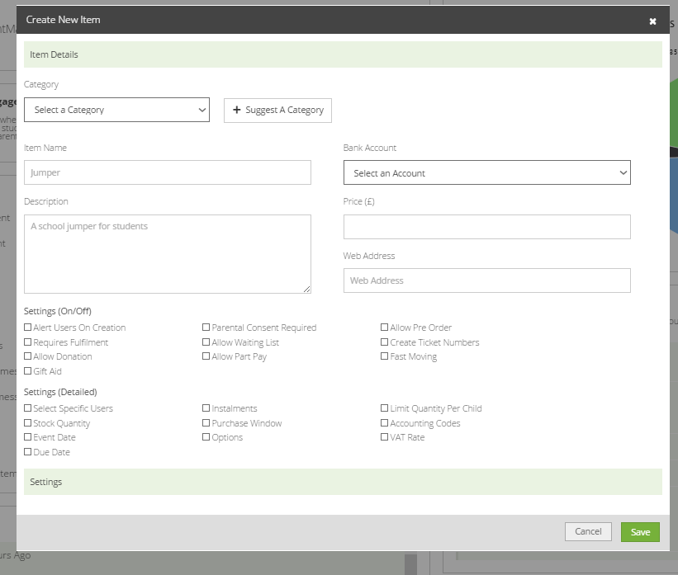

Here you can fill in the details that you need. You can hover over any of the options for more information on what they mean. To add accounting cost codes, you will need to tick the box next to the setting (detailed) named: Accounting Codes:

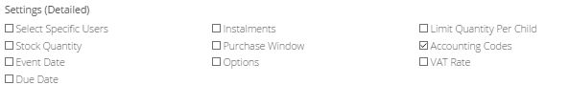

This will then open up the settings for the accounting codes. You can enter in the accounting costs here and then click the ‘save’ button.
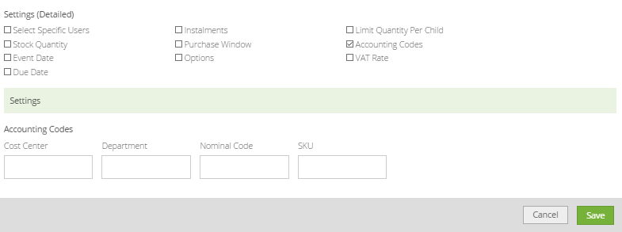

Adding cash/cheques through PMX
If parents make all their payments through PMX, then the balance they owe will show correctly on PMX. However, if they pay some money through PMX and some as cash/cheques, then the PMX balance will not be up to date. A way round this is to use the option in PMX for entering Cash/Cheques as a batch. This will update the PMX balance, and the transactions will then appear in PFM as cash/cheques waiting to be banked. Clearly, you should not ALSO enter them into PFM in the usual way, and this will lead to duplicates. Enter them into PMX and then import entries from PMX ready for banking along with other cash/cheques not related to trips on PMX.
It is much more straightforward if parents do not mix and match online payments with cash and cheques for any given trip, but of course we can’t stop this happening.
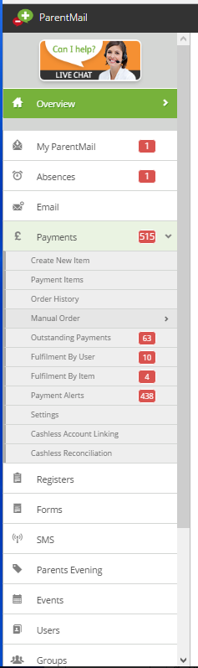
How to process a manual order

When logged into PMX, click onto Payments tab from the menu on the left hand side of PMX. This will then expand into 11 different sub-tabs. Please click onto the ‘manual order’ tab.

This will open the Contact Book – search for the student by using the search box, or search by ‘User’ or ‘Group’ type. Once you have selected the student – click ‘Next’.
You will then have the ability to view and select any payment items available for the child. To select an item press the basket option, next to the item.
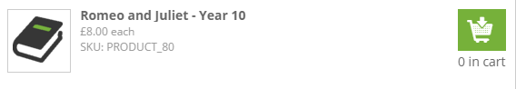
You will then be able to select quantity or size if this option is available. Once you are ready press the “Add to cart” option in the bottom right corner.

You will then need to select ‘View Cart’, review the order and then select ‘Checkout Now’ on the right hand side. You will then be required to record who you are making the payment on behalf of.

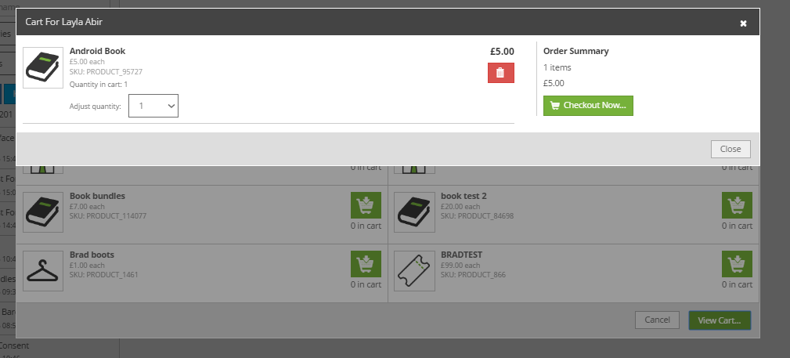

The drop down box under “Select Payee Name” will list all the users who are connected to the student you originally selected from the Contact Book. You can select one of these users OR if the person who has come in or called in to pay for the item is not listed as a user on ParentMail, you can manually input their details. Please note, this will not add them as a user on the system. Once you have done this you will need to select the payment method from the drop down menu. The Payment Method you select will then determine the next page you see. If you select a card you will need to input the card details, for example.

To check that the payment has gone through, go to ‘Order History’ in the Payments Menu and the order you have just processed will be at the top of the list. Click on this to see the details of the payment. You will also receive an email receipt that you have made a manual payment on behalf of the parent, and this will appear on the ‘Manual Payments for a selected date range’ report. You can use this email as a receipt, print it or email it to the parent.

Downloading the list of payments received from PMX
You will be receiving payments from parents for trips etc., on an ongoing basis. Depending on the quantity, and how frequently you wish to update PFM with this information, you will need to download the report showing the payments received. If you want PFM to be up to date, then this will need to be done pretty regularly.
To download the report, go into PMX and to the REPORTS option on the LH menu - then select Payment Reports from the sub menu.

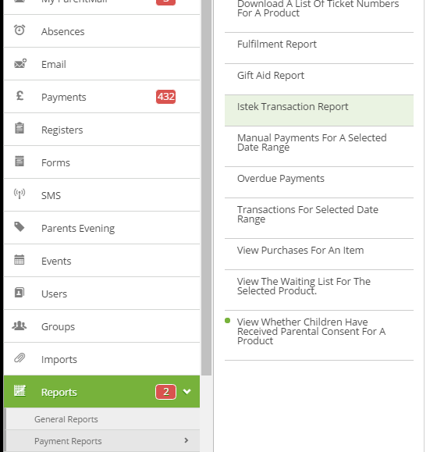
Then, select the ISTEK transaction report from the payment report menu to the right.
You will then be asked to select a date range, use the calendars as shown below to do so.
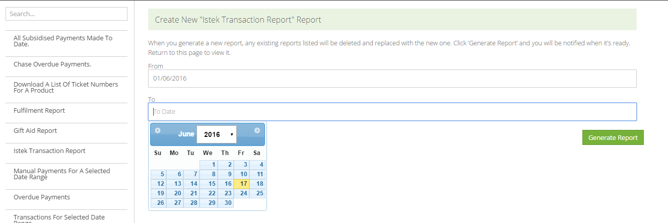
Click Generate Report once you are happy with the date range selected.
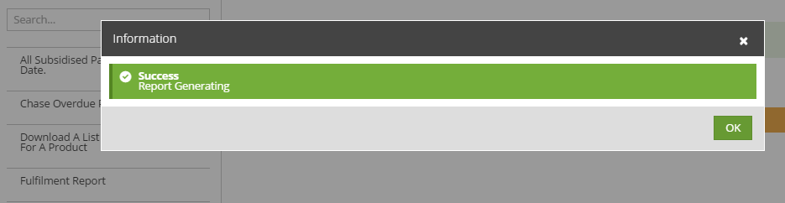
After a short time, your report will be ready to download, press the CSV button to do this.
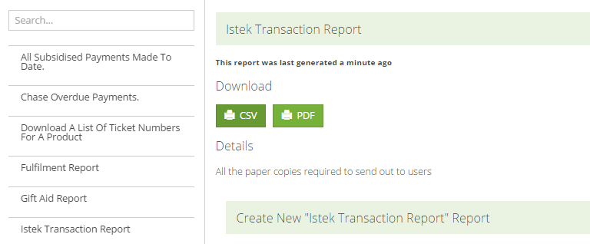

SAVE the report into the UNPROCESSED INTERNET PAYMENTS folder within the PFM folder. Make sure there are NO other files in this folder.

.
Import the payments into PFM
Go into PFM – to Trans Entry – Receipts – Internet Receipts. Click on the button bottom left to READ INTERNET RECEIPTS FILE

Once complete, the grid onscreen will be populated with all the online payments received since your last download. The Trans Entry –Receipts – By Short Code will also have entries added for any cash/cheque you entered onto PMX. You can now BANK IT

Enter PMX’s service invoice
Periodically Parentmail will issue a charges bill. You will receive email notification of this bill.
The invoice will need to be reflected on PFM. You will probably need to create a new short code for PMX Charges.
Enter the transaction through Trans Entry – Direct Postings – Payments. Select the short code, and use the appropriate bank account (as it will be automatically deducted from here)

Reconciliation –the final stage!
The last step is to reconcile the PMX transactions.
All PMX transactions are allocated a BATCH NUMBER – but NOT UNTIL Parentmail actually pay you the money.
When a payment is received from Parentmail, go to TRANS ENTRY – BANK STATEMENTS – choose your bank account. Locate any one item within that batch – the batch number shows, as does the batch total, If the total agrees with the bank statement, press F1 to tick all the items.
NB – you must have the BATCH option ticked at the bottom left of the PFM Bank Rec screen.

